CSE 5543 Lab 3 Results
Zhe Yuan, yuan.1435
Command: (Windows)
PS > .\subdivide_grid.exe -off 1 '.\Lab3 grids\wave-A.grid2D'
Writing .\Lab3 grids\wave-A-subdiv-1.grid2D.
Writing .\Lab3 grids\wave-A-subdiv-1.off.
PS > .\subdivide_grid.exe -off 3 '.\Lab3 grids\wave-A.grid2D'
Writing .\Lab3 grids\wave-A-subdiv-3.grid2D.
Writing .\Lab3 grids\wave-A-subdiv-3.off.
PS > .\subdivide_grid.exe -off 1 '.\Lab3 grids\sphere-A.grid2D'
Writing .\Lab3 grids\sphere-A-subdiv-1.grid2D.
Writing .\Lab3 grids\sphere-A-subdiv-1.off.
PS > .\subdivide_grid.exe -off 3 '.\Lab3 grids\sphere-A.grid2D'
Writing .\Lab3 grids\sphere-A-subdiv-3.grid2D.
Writing .\Lab3 grids\sphere-A-subdiv-3.off.
PS > .\subdivide_grid.exe -off 1 '.\Lab3 grids\torus-A.grid2D'
Writing .\Lab3 grids\torus-A-subdiv-1.grid2D.
Writing .\Lab3 grids\torus-A-subdiv-1.off.
PS > .\subdivide_grid.exe -off 3 '.\Lab3 grids\torus-A.grid2D'
Writing .\Lab3 grids\torus-A-subdiv-3.grid2D.
Writing .\Lab3 grids\torus-A-subdiv-3.off.
Results:
 | Subdivision iterations 1 | Subdivision iterations 3
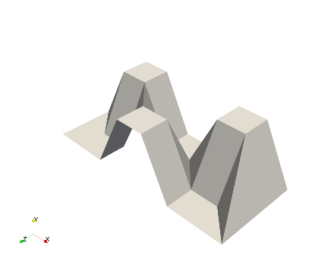Wave | 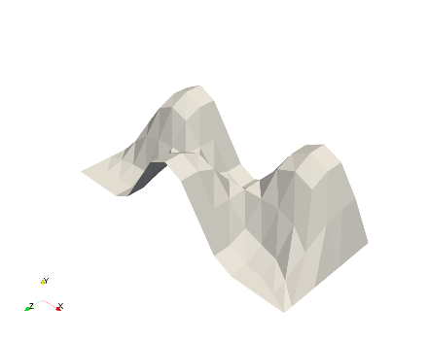 | 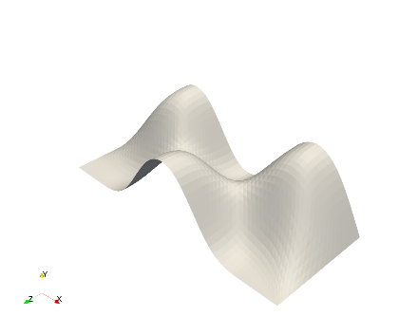
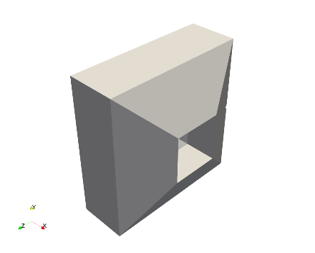Sphere | 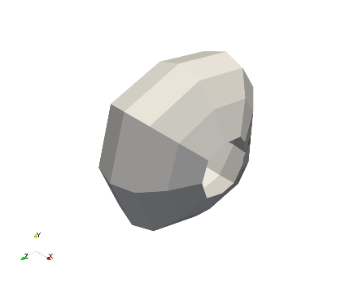 | 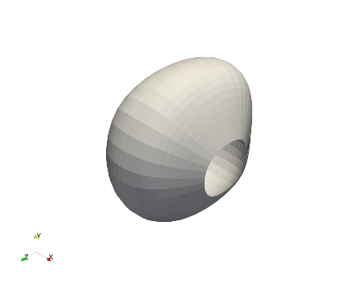
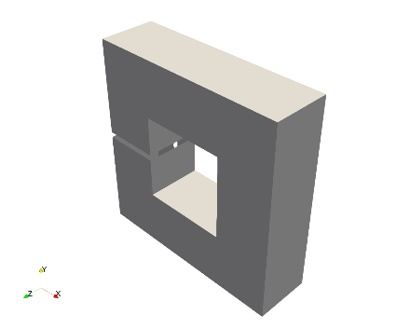Torus | 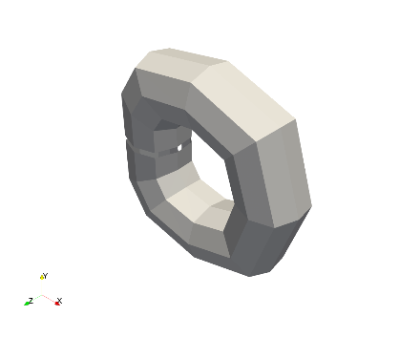 | 